Sprint:

A sprint is a short and fixed time frame during which a specific set of tasks are meant to be performed.

Sprints are timeboxed iterations of a continuous project development cycle—short repeatable phases that last between one and four weeks.

An approach that takes large, complex product development projects and breaks them down into smaller, more manageable pieces.

**Each sprint has the following characteristics:**

* It maintains a consistent duration throughout the whole development effort.
* A new sprint immediately begins after the successful conclusion of the previous one.
* The sprint has a predetermined start and end date.

Sprint Backlog:

The Sprint Backlog is a plan by and for the Developers. It is a highly visible, real-time picture of the work that the Developers plan to accomplish during the Sprint in order to achieve the Sprint Goal.(desired outcome)

Product Owner:

The product owner is responsible for all the interaction and communication of the stakeholders by ensuring the right balance among all.

Besides this, the product owner is responsible for the release management of the model. He tends to decide whether the product needs to be delivered in iterations or continuous delivery.

Alongside this, the product owner guides the development team on what functionalities are assumed to be delivered first and which ones must be given more priority.

Product Backlog:

A**product backlog** is a prioritized list of tasks — including new features to build, bugs to fix, improvements to implement, etc. — that is derived from the product requirements and roadmap. It is a scrum artifact that serves as a to-do list for agile development teams.

One of the main roles of a Product Owner is to manage the product backlog. This may include the following activities:

* The product backlog is clearly defined, and all the items need to be mentioned elaborately.
* Prioritize and order the product backlog. So that important tasks are given topmost priority.
* Prioritize work items and product backlog, this must be in line with customer vision and goals.
* Review the work done by the development team and provide constant feedback.
* The Product Owner must ensure that the product backlog is communicated clearly to all team members.

SCRUM:

It is a type of agile framework within which people can address complex adaptive problem while productivity and creativity of delivering product is at highest possible values.

SCRUM Master:

The scrum master acts as a leader who guides the development team.

He facilitates the set of development activities done by the team.

The scrum master is responsible for letting the persons outside the scrum team understand the scrum practices.

To know more about sprint and sprint workflow:

* Plan - The sprint begins with sprint planning, where the product owner and development team collaborate to plan the work for sprint.
* Design - Design activities to plan the implementation of the selected backlog items.
* Develop – Thew write code and develop features.
* Test – After development of feature testing team is needed to test the features tp meet the specific requirements.
* Deploy – Finally the feature is ready for deployment.
* Review – After deployment, the development team present the completed feature to stakeholders for review.
* Launch – After retrospective stage, the development team is ready to launch the feature.

**Daily Scrum:**

Every day throughout the sprint, the team members conduct stand-up meetings (also called **Daily Scrum**). The meetings typically last 15 mins and the discussions revolve around all team members.

**Spring Retrospective:**

It is held after the sprint review at the end of each sprint. During the retrospective, the team self-identifies elements of the process that did or did not work during the sprint, along with potential solutions.

**Incremental:**

At the end of each sprint, a fully functioning increment of the product is shipped for delivery. In Agile, the priority always remains customer satisfaction and fast delivery. The product increment must have satisfied all the quality standards and client requirements.

Scrum framework and example:

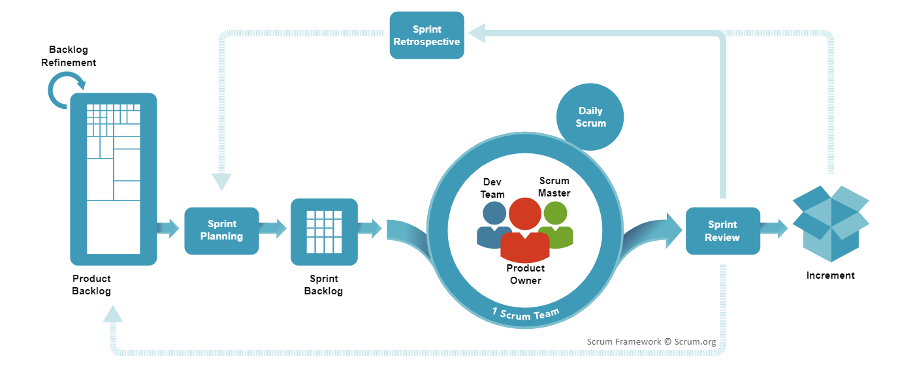

Example – Table Reservation feature for a Restaurant

Product Owner – Consider John as a product owner who understand the requirements of the client.

Product Backlog – Table Reservation feature as a user story to the product backlog. Describes the customers to reserve tables at the restaurant for specific date and time.

Sprint Planning – The team begins Sprint 1 with a goal to implement the table reservation feature from the Product Backlog within a two-week timeframe.

Sprint Backlog – It includes task like what details are needed to reserve a table and available time and date.

Scrum master – Is responsible for the development team.

Daily Scrum – It is a short meeting to discuss what have they done .

Sprint Review – Table Reservation feature is ready for the review, and it can be presented to the stakeholder and gather feedback for it.

Sprint Retrospective – After review, identify what areas to be improved for future sprint.

Agile:

An agile framework is a selected set of practices, roles, artifacts, and activities that help groups implement the agile philosophy in their software development tasks. There are many agile frameworks, each with its very own strengths, weaknesses, and suitability for specific contexts.